**Chapter-1**

# INTRODUCTION

* 1. **Computer Graphics**

Computer graphics are [graphics](http://en.wikipedia.org/wiki/Graphics) created using [computers](http://en.wikipedia.org/wiki/Computer) and the representation of [image](http://en.wikipedia.org/wiki/Image) data by a computer specifically with help from specialized graphic hardware and software.

The interaction and understanding of computers and interpretation of data has been made easier because of computer graphics. Computer graphic development has had a significant impact on many types of media and have revolutionized [animation,](http://en.wikipedia.org/wiki/Animation) [movies](http://en.wikipedia.org/wiki/Movies) and the [video game](http://en.wikipedia.org/wiki/Video_game) industry.

Computer graphics is widespread today. Computer imagery is found on television, in newspapers, for example in weather reports, or for example in all kinds of medical investigation and surgical procedures. A well-constructed [graph](http://en.wikipedia.org/wiki/Chart) can present complex statistics in a form that is easier to understand and interpret. In the media "such graphs are used to illustrate papers, reports, thesis", and other presentation material.

Computer generated imagery can be categorized into several different types: two dimensional (2D), three dimensional (3D), and animated graphics. As technology has improved, 3D computer graphics have become more common, but 2D computer graphics are still widely used. Computer graphics has emerged as a sub-field of [computer science](http://en.wikipedia.org/wiki/Computer_science) , which studies methods for digitally synthesizing and manipulating visual content. Over the past decade, other specialized fields have been developed like [information visualization,](http://en.wikipedia.org/wiki/Information_visualization) and [scientific visualization](http://en.wikipedia.org/wiki/Scientific_visualization) more concerned with "the visualization of [three dimensional](http://en.wikipedia.org/wiki/Three-dimensional_space) phenomena (architectural, meteorological, medical, [biological,](http://en.wikipedia.org/wiki/Biological_Data_Visualization) etc.), where the emphasis is on realistic renderings of volumes, surfaces, illumination sources, and so forth, perhaps with a dynamic (time) component".

OpenGL Utility Toolkit (GLUT) was developed by Mark Kilgard, it Hides the complexities of differing window system APIs, Default user interface for class projects, Glut routines have prefix glut, Eg- glutCreateWindow().

**1.2 OpenGL Technology**

OpenGL is a graphics application programming interface (API) which was originally developed by Silicon Graphics. OpenGL is not in itself a programming language, like C++, but functions as an API that can be used as a software development tool for graphics applications. The term Open is significant in that OpenGL is operating system independent. GL refers to graphics language. OpenGL also contains a standard library referred to as the OpenGL Utilities (GLU). GLU contains routines for setting up viewing projection matrices and describing complex objects with line and polygon approximations.

OpenGL gives the programmer an interface with the graphics hardware. OpenGL is a low-level, widely supported modelling and rendering software package, available on all platforms. It can be used in a range of graphics applications, such as games, CAD design, modelling.

OpenGL is the core graphics rendering option for many 3D games, such as Quake 3. The providing of only low-level rendering routines is intentionalbecause this gives the programmer a great control and flexibility in his applications. These routines can easily be used to build high-level rendering and modelling libraries. The OpenGL Utility Library (GLU) does exactly this, and is included in most OpenGL distributions! OpenGL was originally developed in 1992 by Silicon Graphics, Inc., (SGI), as a multi-purpose platform independent graphics API. Since 1992 all of the development of OpenGL.

OpenGL is a software interface to graphics hardware. This interface consists of about 150 distinct commands that you use to specify the objects and operations needed to produce interactive three-dimensional applications.

OpenGL is designed as a streamlined, hardware-independent interface to be implemented on many different hardware platforms. To achieve these qualities, no commands for performing windowing tasks or obtaining user input are included in OpenGL; instead, you must work through whatever windowing system controls the particular hardware you are using. The OpenGL

Visualization Programming Pipeline:

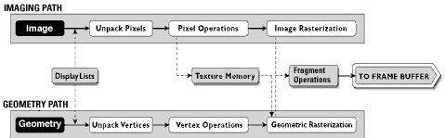

Figure. 1.1: OpenGL Visualization Programming Pipeline

OpenGL operates on image data as well as geometric primitives. Simplifies Software Development, Speeds Time-to-Market.

Routines simplify the development of graphics software—from rendering a simple geometric point, line, or filled polygon to the creation of the most complex lighted and texture mapped NURBS curved surface. OpenGL gives software developers access to geometric and image primitives, display lists, modeling transformations,lighting and texturing, anti-aliasing, blending, and many other features. Every conforming OpenGL implementation includes the full complement of OpenGL functions. The well-specified OpenGL standard has language bindings for C, C++, FORTRAN, Ada, and Java. All licensed OpenGL implementations come from a single specification and language binding document and are required to pass a set of conformance tests. Applications utilizing OpenGL functions are easily portable across a wide array of platforms for maximized programmer productivity and shorter time-to-market.

All elements of the OpenGL state—even the contents of the texture memory and the frame buffer—can be obtained by an OpenGL application. OpenGL also supports visualization applications with 2D images treated as types of primitives that can be manipulated just like 3D geometric objects. As shown in the OpenGL visualization programming pipeline diagram above.

* 1. **Project Description:**

In this project, we strive to obtain a 3-Dimensional Model of the Solar System. The principle behind the working of the project is that, we use spheres to create the objects and use images for the textures. We achieve this by taking an image of .JPEG or .JPG form and use certain tools to obtain a Truevision Graphics Adapter (.tga) File. This file format is widely used for 3D model texture mapping. Resizing is done internally when this process occurs; we specify the width and the depth scaling during the conversion.

We use this file to generate textures for the objects. The user-defined functions handle the image loading and displaying of the texture is obtained using API of OpenGL. We use OpenGL for rendering of the object. We achieve this by storing the textures in an array. This array contains all the textures required for rendering the model. We make use of Lighting API of OpenGL to make the model seem better. Menu list is created using the OpenGL API to display individual objects separately. The model is provided with certain operations that can be performed by the viewer, which is executed using the OpenGL API for keyboard operations. With all the data on hand, we create a 3-Dimensional Model of the Solar System.

We make use of C with OpenGL for entire coding purpose along with some features of Windows. The OpenGL Utility is a Programming Interface. We use light functions to add luster, shade and shininess to graphical objects. The toolkit supports much more functionalities like multiple window rendering, callback event driven processing using sophisticated input devices etc.

**1.4 OpenGL Functions Used:**

This project is developed using CodeBlocks and this project is implemented by making extensive use of library functions offered by graphics package of OpenGL, a summary of those functions follows:

1.4.1 **glBegin() :**

Specifies the primitives that will be created from vertices presented between glBegin and subsequent glEnd.. GL_POLYGON, GL_LINE_LOOP etc.

1.4.2 **glEnd(void) :**

It ends the list of vertices.

1.4.3 **glPushMatrix() :**

*void* ***glPushMatrix*** *(void)*

glPushMatrix pushes the current matrix stack down by one level, duplicating the current matrix.

1.4.4 **glPopMatrix() :**

*void* ***glPopMatrix*** *(void)*

glPopMatrix pops the top matrix off the stack, destroying the contents of the popped matrix. Initially, each of the stacks contains one matrix, an identity matrix.

1.4.5 **glTranslate() :**

*void* ***glTranslate****(GLdouble x, GLdouble y, GLdouble z )*

Translation is an operation that displaces points by a fixed distance in a given direction. *Parameters x*, *y*, *z* specify the *x*, *y*, and *z* coordinates of a translation vector. Multiplies current matrix by a matrix that translates an object by the given x, y and z-values.

1.4.6 **glClear() :**

*void* ***glClear****(GLbitfield mask)*

glClear takes a single argument that is the bitwise *or* of several values indicating which buffer is to be cleared. GL_COLOR_BUFFER_BIT, GL_DEPTH_BUFFER_BIT, GL_ACCUM_ BUFFER_BIT, and GL_STENCIL_BUFFER_BIT. Clears the specified buffers to their current clearing values.

1.4.7 **glClearColor() :**

*void* ***glClearColor****(GLclampf red, GLclampf green, GLclampf blue, GLclampf alpha)*

Sets the current clearing color for use in clearing color buffers in RGBA mode. The red, green, blue, and alpha values are clamped if necessary to the range [0,1]. The default clearing color is (0, 0, 0, 0), which is black.

1.4.8 **glMatrixMode() :**

*void* ***glMatrixMode****(GLenum mode)*

It accepts three values GL_MODELVIEW, GL_PROJECTION and GL_TEXTURE. It specifies which matrix is the current matrix. Subsequent transformation commands affect the specified matrix.

1.4.9 **glutInitWindowPosition() :**

*void* ***glutInitWindowPosition****(int x, int y);*

This API will request the windows created to have an initial position. The arguments x, y indicate the location of a corner of the window, relative to the entire display.

1.4.10 **glLoadIdentity() :**

*void* ***glLoadIdentity****(void);*

It replaces the current matrix with the identity matrix.

1.4.11 **glutInitWindowSize() :**

*void* ***glutInitWindowSize****(int width, int height);*

The API requests windows created to have an initial size. The arguments width and height indicate the window’s size (in pixels). The initial window size and position are hints and may be overridden by other requests.

1.4.12 **glutInitDisplayMode():**

*void* ***glutInitDisplayMode****(unsigned int mode );*

Specifies the display mode, normally the bitwise OR-ing of GLUT display mode bit *masks.* This API specifies a display mode (such as RGBA or color-index, or single or double-buffered) for windows.

1.4.13 **glutSwapBuffers() :**

*void* ***glutSwapBuffers****(void);*

Performs a buffer swap on the *layer in use* for the *current window*. Specifically, glutSwapBuffers promotes the contents of the back buffer of the *layer in use* of the *current window* to become the contents of the front buffer. The contents of the back buffer then become undefined. The update typically takes place during the vertical retrace of the monitor, rather than immediately after glutSwapBuffers is called.

An implicit   glFlush is done by glutSwapBuffers before it returns. Subsequent OpenGL commands can be issued immediately after calling glutSwapBuffers, but are not executed until the buffer exchange is completed.

If the *layer in use* is not double buffered, glutSwapBuffers has no effect.

1.4.14 **glutCreateWindow() :**

*int* ***glutCreateWindow****(char *name);*

The parameter *name* specifies any name for window and is enclosed in double quotes. This opens a window with the set characteristics like display mode, width, height, and so on. The string name will appear in the title bar of the window system*.* The value returned is a unique integer identifier for the window*.* This identifier can be used for controlling and rendering to multiple windows from the same application.

1.4.15 **glutDisplayFunc() :**

*void* ***glutDisplayFunc****(void (*func)(void))*

Specifies the new display callback function. The API specifies the function that’s called whenever the contents of the window need to be redrawn. All the routines need to be redraw the scene are put in display callback function.

1.4.16 **glVertex3f**

*void* ***glVertex3f****(GLfloatx,GLfloat y,GLfloat);*

*x* Specifies the x-coordinate of a vertex.

*y* Specifies the y-coordinate of a vertex.

z Specifies the z-coordinate of a vertex.

The glVertex function commands are used within glBegin/glEnd pairs to specify point, line, and polygon vertices. The current color, normal, and texture coordinates are associated with the vertex when glVertex is called. When only x and y are specified, z defaults to 0.0 and w defaults to 1.0. When x, y, and z are specified, w defaults to 1.0.

1.4.17 **glColor3f**

*void* ***glColor3f****(GLfloat red, GLfloat green, GLfloat blue);*

PARAMETERS:

1. Red: The new red value for the current color.
2. Green: The new green value for the current color.
3. Blue: The new blue value for the current color.

Sets the current color.

1.4.18 **glRotate**():

*void* ***glRotate****( GLfloat angle, GLfloat x, GLfloat y, GLfloat z);*

PARAMETERS:

angle: The angle of rotation, in degrees.

x: The x coordinate of a vector.

y: The y coordinate of a vector.

z: The z coordinate of a vector.

The glRotated and glRotatef functions multiply the current matrix by a rotation matrix.

1.4.19 **glGenTextures():**

*void* ***glGenTexture*** *(GLsizei n, GLuint textures);*

PARAMETERS:

n : Specifies the number of texture names to be generated.

Textures : Specifies an array in which the generated texture names are stored.

glGenTextures returns *n* texture names in *textures*. There is no guarantee that the names form a contiguous set of integers; however, it is guaranteed that none of the returned names was in use immediately before the call to glGenTextures.

1.4.20 **glBindTexture():**

*void* ***glBindTexture*** *(GLenum target, GLuint texture);*

PARAMETERS:

target : Specifies the target to which the texture is bound. Must be one of GL_TEXTURE_1D,GL_TEXTURE_2D, GL_TEXTURE_3D, GL_TEXTURE_1D_ARRAY, GL_TEXTURE_2D_ARRAY,GL_TEXTURE_RECTANGLE, GL_TEXTURE_CUBE_MAP, GL_TEXTURE_CUBE_MAP_ARRAY,GL_TEXTURE_BUFFER, GL_TEXTURE_2D_MULTISAMPLE or GL_TEXTURE_2D_MULTISAMPLE_ARRAY.

texture : Specifies the name of a texture.

1.4.21 **glutInit():**

***glutInit****(int *argcp, char **argv);*

PARAMETERS:

argcp : A pointer to the program's unmodified argc variable from main. Upon return, the value pointed to by argcp will be updated, because glutInit extracts any command line options intended for the GLUT library.

argv : The program's unmodified argv variable from main. Like argcp, the data for argv will be updated because glutInit extracts any command line options understood by the GLUT library.

*glutInit(&argc,argv);*

glutInit is used to initialize the GLUT library.

1.4.22 **glutMainLoop ():**

*void* ***glutMainLoop*** *(void);*

*glutMainLoop();*

glutMainLoop enters the GLUT event processing loop.

1.4.23 **glLightfv():**

*void* ***glLightfv****(GLenum light, GLenum pname, GLfloat *params);*

The glLightfv function returns light source parameter values.

PARAMETERS:

Light: The identifier of a light. The number of possible lights depends on the implementation, but at least eight lights are supported. They are identified by symbolic names of the form GL_LIGHTi where i is a value: 0 to GL_MAX_LIGHTS - 1.

Pname: A light source parameter for light. The following symbolic names are accepted:

GL_DIFFUSE: The params parameter contains four integer or floating-point values that specify the diffuse RGBA intensity of the light. Integer values are mapped linearly such that the most positive represent able value maps to 1.0, and the most negative represent able value maps to 1.0. Floating-point values are mapped directly. Neither integer nor floating-point values are clamped. The default diffuse intensity is (0.0, 0.0, 0.0, 1.0) for all lights other than light zero. The default diffuse intensity of light zero is (1.0, 1.0, 1.0, 1.0).

GL_SPECULAR: The params parameter contains four integer or floating-point values that specify the specular RGBA intensity of the light. Integer values are mapped linearly such that the most positive represent able value maps to 1.0, and the most negative represent able value maps to 1.0. Floating-point values are mapped directly. Neither integer nor floating-point values are clamped. The default specular intensity is (0.0, 0.0, 0.0, 1.0) for all lights other than light zero. The default specular intensity of light zero is (1.0, 1.0, 1.0, 1.0).

GL_AMBIENT: The params contains four integer or floating-point values that specify the ambient RGBA intensity of the light. Integer values are mapped linearly such that the most positive represent able value maps to 1.0, and the most negative representable value maps to -1.0 . Floating-point values are mapped directly. Neither integer nor floating-point values are clamped. The initial ambient light intensity is (0,0, 0, 1).

*glLightfv(GL_LIGHT1,GL_POSITION,pos);*

1.4.24 **glEnable():**

*void* ***glEnable****(GLenum cap);*

Ex: glEnable(GL_CULL_FACE);

PARAMETERS:

cap: A symbolic constant indicating an OpenGL capability.

The glEnable enables OpenGL capabilities.

1.4.25 **glDisable():**

*void* ***glDisable*** *(GLenum cap);*

Ex: glDisable (GL_CULL_FACE);

PARAMETERS:

cap: Specifies a symbolic constant indicating a GL capability.

The glDisable disables OpenGL capabilities.

1.4.26 **gluNewQuadric():**

*GLUquadric\** ***gluNewQuadric****(void);*

Performs a buffer swap on the *layer in use* for the *current window*. Specifically, glutSwapBuffers promotes the contents of the back buffer of the *layer in use* of the *current window* to become the contents of the front buffer. The contents of the back buffer then become undefined. The update typically takes place during the vertical retrace of the monitor, rather than immediately after glutSwapBuffers is called.

An implicit   glFlush is done by glutSwapBuffers before it returns. Subsequent OpenGL commands can be issued immediately after calling glutSwapBuffers, but are not executed until the buffer exchange is completed.

If the *layer in use* is not double buffered, glutSwapBuffers has no effect.

1.4.27 **gluQuadricNormals():**

*void* ***gluQuadricNormals*** *(GLUquadric* quad, GLenum normal);*

PARAMETERS:

Quad : Specifies the quadrics object (created with gluNewQuadric).

Normal : Specifies the quadrics object (created with gluNewQuadric).

gluQuadricNormals specifies what kind of normals are desired for quadrics rendered with *quad*. The legal values are as follows:

GLU_NONE :No normals are generated.

GLU_FLAT : One normal is generated for every facet of a quadric.

GLU_SMOOTH : One normal is generated for every vertex of a quadric. This is the initial value.

1.4.28 **gluQuadricTexture():**

*void* ***gluQuadricTexture*** *(GLUquadric* quad, GLboolean texture);*

PARAMETERS:

Quad : Specifies the quadrics object (created with gluNewQuadric).

Texture : Specifies a flag indicating if texture coordinates should be generated.

gluQuadricTexture specifies if texture coordinates should be generated for quadrics rendered with *quad*. If the value of *texture* is GLU_TRUE, then texture coordinates are generated, and if *texture* is GLU_FALSE, they are not. The initial value is GLU_FALSE.

The manner in which texture coordinates are generated depends upon the specific quadric rendered.

1.4.29 **gluLookAt():**

*void* ***gluLookAt*** *(GLdouble eyeX, GLdouble eyeY, GLdouble eyeZ,*

*GLdouble centerX, GLdouble centerY, GLdouble centerZ,*

*GLdouble upX, GLdouble upY, GLdouble upZ);*

PARAMETERS:

eyeX, eyeY, eyeZ : Specifies the position of the eye point.

centerX, centerY, centerZ :Specifies the position of the reference point.

upX, upY, upZ :Specifies the direction of the *up* vector.

gluLookAt creates a viewing matrix derived from an eye point, a reference point indicating the center of the scene, and an *UP* vector.

1.4.30 **gluSphere():**

*void* ***gluSphere****(GLUquadric* quad, GLdouble radius, GLint slices, GLint stacks);*

PARAMETERS:

Quad : Specifies the quadrics object (created with gluNewQuadric).

Radius : Specifies the radius of the sphere.

Slices : Specifies the number of subdivisions around the *z* axis (similar to lines of longitude).

Stacks : Specifies the number of subdivisions along the *z* axis (similar to lines of latitude).

gluSphere draws a sphere of the given radius centered around the origin. The sphere is subdivided around the z axis into slices and along the z axis into stacks (similar to lines of longitude and latitude).

1.4.31 **glViewport():**

*void* ***glViewport*** *(GLint x, GLint y, GLsizei width, GLsizei height);*

PARAMETERS:

x,y : Specify the lower left corner of the viewport rectangle, in pixels. The initial value is (0,0).

width, height : Specify the width and height of the viewport. When a GL context is first attached to a window, *width* and *height* are set to the dimensions of that window.

1.4.32 **glFrustum():**

*void* ***glFrustum****(GL double left, GLdouble right,*

*GLdouble bottom, GLdouble top,*

*GLdouble nearVal, GLdouble farVal);*

PARAMETERS:

left, right : Specify the coordinates for the left and right vertical clipping planes.

bottom, top : Specify the coordinates for the bottom and top horizontal clipping planes.

nearVal, farVal : Specify the distances to the near and far depth clipping planes. Both distances

must be positive.

glFrustum describes a perspective matrix that produces a perspective projection.

1.4.33 **glutTimerFunc():**

*void* ***glutTimerFunc****(unsigned int msecs, void (*func)(int value), value);*

glutTimerFunc registers the timer callback func to be triggered in at least msecs milliseconds. The value parameter to the timer callback will be the value of the value parameter to glutTimerFunc. Multiple timer callbacks at same or differing times may be registered simultaneously.

The number of milliseconds is a lower bound on the time before the callback is generated. GLUT attempts to deliver the timer callback as soon as possible after the expiration of the callback's time interval.

There is no support for canceling a registered callback. Instead, ignore a callback based on its value parameter when it is triggered.

1.4.34 **glCreateMenu():**

*int* ***glutCreateMenu*** *(void (*func)(int value));*PARAMETERS:

func : The callback function for the menu that is called when a menu entry from the menu is

selected. The value passed to the callback is determined by the value for the selected

menu entry.

glutCreateMenu creates a new pop-up menu and returns a unique small integer identifier. The range of allocated identifiers starts at one. The menu identifier range is separate from the window identifier range. Implicitly, the *current menu* is set to the newly created menu. This menu identifier can be used when calling glutSetMenu.

When the menu callback is called because a menu entry is selected for the menu, the *current menu* will be implicitly set to the menu with the selected entry before the callback is made.

1.4.35 **glutAddMenuEntry():**

*void* ***glutAddMenuEntry*** *(char *name, int value);*

PARAMETERS:

name : ASCII character string to display in the menu entry.

value : Value to return to the menu’s callback function if the menu entry is selected.

glutAddMenuEntry adds a menu entry to the bottom of the *current menu*. The string name will be displayed for the newly added menu entry. If the menu entry is selected by the user, the menu's callback will be called passing value as the callback's parameter.

1.4.36 **glutAddSubMenu():**

*void* ***glutAddSubMenu*** *( char *name, int menu);*

PARAMETERS:

Name : ASCII character string to display in the menu item from which to cascade the sub-menu.

Menu : Identifier of the menu to cascade from this sub-menu menu item.

glutAddSubMenu adds a sub-menu trigger to the bottom of the *current menu*. The string name will be displayed for the newly added sub-menu trigger. If the sub-menu trigger is entered, the sub-menu numbered menu will be cascaded, allowing sub-menu menu items to be selected.

1.4.37 **glutAttachMenu ():**

*void* ***glutAttachMenu*** *(int button);*

PARAMETERS:

Button : The button to attach a menu or detach a menu.

glutAttachMenu attaches a mouse button for the *current window* to the identifier of the *current menu*. By attaching a menu identifier to a button, the named menu will be popped up when the user presses the specified button. button should be one of GLUT_LEFT_BUTTON, GLUT_MIDDLE_BUTTON, and GLUT_RIGHT_BUTTON. Note that the menu is attached to the button by identifier, not by reference.

1.4.38 **glutReshapeFunc():**

*void* ***glutReshapeFunc*** *(void (*func) (int width, int height));*

PARAMETERS:

Func : The new reshape callback function.

glutReshapeFunc sets the reshape callback for the *current window*. The reshape callback is triggered when a window is reshaped. A reshape callback is also triggered immediately before a window's first display callback after a window is created or whenever an overlay for the window is established. The width and height parameters of the callback specify the new window size in pixels. Before the callback, the *current window* is set to the window that has been reshaped.

If a reshape callback is not registered for a window or NULL is passed to glutReshapeFunc (to deregister a previously registered callback), the default reshape callback is used. This default callback will simply call glViewport(0,0,width,height) on the normal plane (and on the overlay if one exists).

If an overlay is established for the window, a single reshape callback is generated. It is the callback's responsibility to update both the normal plane and overlay for the window (changing the *layer in use* as necessary).

When a top-level window is reshaped, subwindows are not reshaped. It is up to the GLUT program to manage the size and positions of subwindows within a top-level window. Still, reshape callbacks will be triggered for subwindows when their size is changed using glutReshapeWindow.

1.4.39 **glutKeyboardFunc():**

*void* ***glutKeyboardFunc*** *(void (*func) (unsigned char key, int x, int y));*

PARAMETERS:

Func : The new keyboard callback function.

glutKeyboardFunc sets the keyboard callback for the *current window*. When a user types into the window, each key press generating an ASCII character will generate a keyboard callback. The key callback parameter is the generated ASCII character. The state of modifier keys such as Shift cannot be determined directly; their only effect will be on the returned ASCII data. The x and y callback parameters indicate the mouse location in window relative coordinates when the key was pressed. When a new window is created, no keyboard callback is initially registered, and ASCII key strokes in the window are ignored. Passing NULL to glutKeyboardFunc disables the generation of keyboard callbacks.

1.4.40 **glutPostRedisplay ():**

*void* ***glutPostRedisplay*** *(void);*

Mark the normal plane of *current window* as needing to be redisplayed. The next iteration through glutMainLoop, the window's display callback will be called to redisplay the window's normal plane. Multiple calls to glutPostRedisplay before the next display callback opportunity generates only a single redisplay callback. glutPostRedisplay may be called within a window's display or overlay display callback to re-mark that window for redisplay.

Logically, normal plane damage notification for a window is treated as a glutPostRedisplay on the damaged window.

**Chapter-2**

# REQUIREMENTS SPECIFICATION

**2.1 Hardware requirements**:

* Pentium or higher processor.
* 256 MB or more RAM.
* A standard keyboard, and Microsoft compatible mouse
* VGA monitor.
* Hard Disk Space: 4.0 GB

**2.2 Software requirements**:

* The graphics package has been designed for OpenGL; hence, the machine must have Dev C++.
* Software installed preferably 6.0 or later versions with mouse driver installed.
* GLUT libraries, Glut utility toolkit must be available.
* Operating System**:** Windows
* Version of Operating System**:** Windows XP, Windows NT and Higher
* The package is implemented using Microsoft visual C++, under the windows platform. OpenGL and associated toolkits are used for the package development.
* OpenGL , a software interface for graphics hardware with built in graphics libraries like glut and glut32, and header files like glut.h.

**Chapter-3**

# INTERFACE AND ARCHITECTURE

**3.1 Flow Diagram:**

START

Convert the required image for texture into TGA format

Store the converted images in desired location for accessing

Main ()

OpenGL function Initialization

Menu Function

Reshape Function

Display Function

Keyboard Function

Stored Data (TGA Files)

**FIG: The flow diagram for displaying the 3D Model of Solar System**

OpenGL is a software tool for developing the graphics objects. OpenGL library called GLUT i.e. Graphics Library Utility toolkit supports graphics system with the necessary modelling and rendering techniques. The Lighting system is a technique for displaying graphic objects on the monitor and displaying the light effects. It provides the following functionalities.

**3.2 Initialization**

This function is the initial stage of the system where the system initializes the various aspects of the graphics system based on the user requirements, which include Command line processing, window system initialization and also the initial window creation state is controlled by these routines.

**3.3 Event Processing**

This routine enters GLUT’s event processing loop. This routine never returns, and it continuously calls GLUT callback as and when necessary. This can be achieved with the help of the callback registration functions. These routines register callbacks to be called by the GLUT event processing loop.

**Chapter-4**

# IMPLEMENTATION

**Step 1:** The required texture image must first be converted into a TGA format image which is used by the tgaload function.

**Step 2**: The TGA format image is then stored in the desired location and then it is provided to the program to perform the required operations to display the texture.

**4.1 Source Code**

**4.1.1 The header files are:**

#include <windows.h>

#include <GL/glut.h>

#include <math.h>

#include "tgaload.c"

**4.1.2 The code for creating the orbits for the planets:**

void generateOrbit(void)

{

for (int i = 0; i <= 360; i++)

{//Mercury

x1[i][0] = sin(i*3.1416/180)*2.4;

x1[i][1] = cos(i*3.1416/180)*2.4;

//Venus

x2[i][0] = sin(i*3.1416/180)*3.2;

x2[i][1] = cos(i*3.1416/180)*3.2;

//Earth

x3[i][0] = sin(i*3.1416/180)*4.2;

x3[i][1] = cos(i*3.1416/180)*4.2;

//Moon

x10[i][0] = sin(i*3.1416/180)*0.6;

x10[i][1] = cos(i*3.1416/180)*0.6;

//Mars

x4[i][0] = sin(i*3.1416/180)*5.5;

x4[i][1] = cos(i*3.1416/180)*5.5;

//Jupiter

x5[i][0] = sin(i*3.1416/180)*7;

x5[i][1] = cos(i*3.1416/180)*7;

//Saturn

x6[i][0] = sin(i*3.1416/180)*8.8;

x6[i][1] = cos(i*3.1416/180)*8.8;

//Uranus

x7[i][0] = sin(i*3.1416/180)*10.5;

x7[i][1] = cos(i*3.1416/180)*10.5;

//Neptune

x8[i][0] = sin(i*3.1416/180)*12;

x8[i][1] = cos(i*3.1416/180)*12;

//Pluto

x9[i][0] = sin(i*3.1416/180)*13.2;

x9[i][1] = cos(i*3.1416/180)*13.2;

}

}

**4.1.3 The Reshape Function:**

void reshape(int w, int h)

{

glViewport (0, 0, (GLsizei) w, (GLsizei) h);

glMatrixMode (GL_PROJECTION);

glLoadIdentity ();

glFrustum (-2.0, 2.0, -2.0, 2.0, 1.5, 30.0);

glMatrixMode (GL_MODELVIEW);

glLoadIdentity ();

}

**4.1.4 The code for drawing and rotating the planets:**

void planets ()

{//SUN

glPushMatrix();

gluLookAt (worldX, worldY, worldZ, 0.0, 0.0, 0.0, 0.0, 0.0, 1.0);

glTranslatef(Xvalue, 0.0, Yvalue);

glRotatef(Angle/25, 0.0, 0.0, 1.0);

glBindTexture ( GL_TEXTURE_2D, texture_id[0] );

gluSphere(sphere,2,100,100);

glPopMatrix();

//MERCURY

glPushMatrix();

gluLookAt (worldX, worldY, worldZ, 0.0, 0.0, 0.0, 0.0, 0.0, 1.0);

if (MoveMerc==360)

MoveMerc = 0;

glTranslatef(x1[MoveMerc][1], x1[MoveMerc][0], 0.0);

glRotatef(Angle, 0.0, 0.0, 1.0);

glBindTexture ( GL_TEXTURE_2D, texture_id[1] );

gluSphere(sphere, 0.25, 100, 100);

glPopMatrix();

//VENUS

glPushMatrix();

gluLookAt (worldX, worldY, worldZ, 0.0, 0.0, 0.0, 0.0, 0.0, 1.0);

if (MoveVenus == 720)

MoveVenus = 0;

glTranslatef(x2[MoveVenus/2][1], x2[MoveVenus/2][0], 0.0);

glRotatef(Angle, 0.0, 0.0, -1.0);

glBindTexture ( GL_TEXTURE_2D, texture_id[2] );

gluSphere(sphere, 0.28, 100, 100);

glPopMatrix();

//EARTH

glPushMatrix();

gluLookAt (worldX, worldY, worldZ, 0.0, 0.0, 0.0, 0.0, 0.0, 1.0);

if(MoveEarth==1080)

MoveEarth = 0;

glTranslatef(x3[MoveEarth/3][1], x3[MoveEarth/3][0], 0.0);

glRotatef(Angle*2, 0.1, 0.3, 0.7);

glBindTexture(GL_TEXTURE_2D, texture_id[3]);

gluSphere(sphere, 0.3, 100, 100);

//MOON

if (MoveMoon == 360)

MoveMoon = 0;

glTranslatef(x10[MoveMoon][1], x10[MoveMoon][0], 0.0); //glTranslated(-0.3,-0.3,0.3);

glBindTexture ( GL_TEXTURE_2D, moon_id[0] );

gluSphere (sphere, 0.1, 100, 100);

glPopMatrix();

//MARS

glPushMatrix();

gluLookAt (worldX, worldY, worldZ, 0.0, 0.0, 0.0, 0.0, 0.0, 1.0);

if (MoveMars == 1440)

MoveMars = 0;

glTranslatef(x4[MoveMars/4][1], x4[MoveMars/4][0], 0.0);

glRotatef(Angle, 0.0, 0.0, 1.0);

glBindTexture ( GL_TEXTURE_2D, texture_id[4] );

gluSphere(sphere, 0.28, 100, 100);

glPopMatrix();

//JUPITER

glPushMatrix();

gluLookAt (worldX, worldY, worldZ, 0.0, 0.0, 0.0, 0.0, 0.0, 1.0);

if (MoveJup == 1800)

MoveJup = 0;

glTranslatef(x5[MoveJup/5][1], x5[MoveJup/5][0], 0.0);

glRotatef(Angle, 0.0, 0.0, 0.1);

glBindTexture ( GL_TEXTURE_2D, texture_id[5] );

gluSphere(sphere, 0.7, 100, 100);

glPopMatrix();

//SATURN

glPushMatrix();

gluLookAt (worldX, worldY, worldZ, 0.0, 0.0, 0.0, 0.0, 0.0, 1.0);

if(MoveSaturn==2160)

MoveSaturn = 0;

glTranslatef(x6[MoveSaturn/6][1], x6[MoveSaturn/6][0], 0.0);

glRotatef(Angle, 0.0, 0.0, 0.1);

glBindTexture ( GL_TEXTURE_2D, texture_id[6] );

gluSphere (sphere, 0.50, 100, 100);

int i = 0;

glBindTexture(GL_TEXTURE_2D, texture_id[10]);

glBegin(GL_QUAD_STRIP);//Saturn Rings

for(i=0; i <= 360; i++)

{

glVertex3f(sin(i*3.1416/180)*0.58, cos(i*3.1416/180)*0.58, 0 );

glVertex3f(sin(i*3.1416/180)*0.61, cos(i*3.1416/180)*0.61, 0 );

}

for (i = 0; i <= 360; i++)

{

glVertex3f(sin(i*3.1416/180)*0.65, cos(i*3.1416/180)*0.65, 0 );

glVertex3f(sin(i*3.1416/180)*0.72, cos(i*3.1416/180)*0.72, 0 );

}

glEnd();

glRotatef(Angle, 0.5, 0.2, 1.5);

glPopMatrix();

//URANUS

glPushMatrix();

gluLookAt (worldX, worldY, worldZ, 0.0, 0.0, 0.0, 0.0, 0.0, 1.0);

if (MoveUr == 2520)

MoveUr = 0;

glTranslatef(x7[(MoveUr/7)][1], x7[(MoveUr/7)][0], 0.0);

glRotatef(Angle, 0.0, 0.0, -0.1);

glBindTexture ( GL_TEXTURE_2D, texture_id[7] );

gluSphere(sphere, 0.4, 100, 100);

glBindTexture(GL_TEXTURE_2D, texture_id[11]);

glBegin(GL_QUAD_STRIP);

for(int i=0; i <= 360; i++)

{

glVertex3f(sin(i*3.1416/180)*0.58, cos(i*3.1416/180)*0.58, 0 );

glVertex3f(sin(i*3.1416/180)*0.61, cos(i*3.1416/180)*0.61, 0 );

}

glEnd();

glPopMatrix();

//NEPTUNE

glPushMatrix();

gluLookAt (worldX, worldY, worldZ, 0.0, 0.0, 0.0, 0.0, 0.0, 1.0);

if (MoveNep == 2880)

MoveNep = 0;

glTranslatef(x8[MoveNep/8][1], x8[MoveNep/8][0], 0.0);

glRotatef(Angle, 0.0, 0.0, 0.1);

glBindTexture ( GL_TEXTURE_2D, texture_id[8] );

gluSphere(sphere, 0.33, 100, 100);

glPopMatrix();

//PLUTO

glPushMatrix();

gluLookAt (worldX, worldY, worldZ, 0.0, 0.0, 0.0, 0.0, 0.0, 1.0);

if (MovePlu == 3240)

MovePlu = 0;

glTranslatef(x9[MovePlu/9][1], x9[MovePlu/9][0], 0.0);

glRotatef(Angle, 0.0, 0.0, 0.1);

glBindTexture ( GL_TEXTURE_2D, texture_id[9] );

gluSphere(sphere, 0.2, 100, 100);

glPopMatrix();

}

**4.1.5 Code for displaying the 3D Model:**

void myDisplay(void)

{ glClear (GL_COLOR_BUFFER_BIT | GL_DEPTH_BUFFER_BIT);

glColor3f (1.0, 1.0, 1.0);

glLoadIdentity();

if (value != 0 && value != 15)

{ glPushMatrix();

gluLookAt (worldX, worldY, worldZ, 0.0, 0.0, 0.0, 0.0, 0.0, 1.0);

glTranslated(Xvalue, 0.0, Yvalue);

glRotatef(Angle, 0.0, 0.0, 1.0);

glDisable(GL_LIGHTING);

glBindTexture(GL_TEXTURE_2D,texture_id[value]);

gluSphere(sphere,4,100,100);

glBegin(GL_QUAD_STRIP);

if (value == 6 || value == 7)

{

if( value ==6)

glBindTexture(GL_TEXTURE_2D, texture_id[10]);

else glBindTexture(GL_TEXTURE_2D, texture_id[11]);

for(int i=0; i <= 360; i++)

{

glVertex3f(sin(i*3.1416/180)*4.38, cos(i*3.1416/180)*4.38, 0 );

glVertex3f(sin(i*3.1416/180)*5.11, cos(i*3.1416/180)*5.11, 0 );

}

}

if (value == 6)

{

for (int i = 0; i <= 360; i++)

{

glVertex3f(sin(i*3.1416/180)*5.5, cos(i*3.1416/180)*5.5, 0 );

glVertex3f(sin(i*3.1416/180)*5.92, cos(i*3.1416/180)*5.92, 0 );

}

}

glEnd();

glEnable(GL_LIGHTING);

glPopMatrix();

}

else if (value == 15)

{

glClear(GL_COLOR_BUFFER_BIT | GL_DEPTH_BUFFER_BIT);

Sun();Mercury();Venus();EarthAndMoon();Mars();

Jupiter();Saturn();Uranus();Neptune();Pluto();

}

glutSwapBuffers();

}

**4.1.6 The code for creating a menu list:**

void menu (int num)

{ if(num == 0)

exit(0);

else value = num;

glutPostRedisplay();

}

void CreateMenuItem(void)

{ submenu_id = glutCreateMenu(menu);

glutAddMenuEntry("Mercury",1);

glutAddMenuEntry("Venus",2);

glutAddMenuEntry("Earth",3);

glutAddMenuEntry("Mars",4);

glutAddMenuEntry("Jupiter",5);

glutAddMenuEntry("Saturn",6);

glutAddMenuEntry("Uranus",7);

glutAddMenuEntry("Neptune",8);

glutAddMenuEntry("Pluto",9);

menu_id = glutCreateMenu(menu);

glutAddSubMenu("Display Planet",submenu_id);

glutAddMenuEntry("Quit", 0);

glutAttachMenu(GLUT_RIGHT_BUTTON);

}

**4.1.7 The Keyboard Function:**

void keys(unsigned char key, int x, int y)

{ switch (key)

{ case 'q': exit(0); break;

case 'y': worldY -= 1.0f; break;

case 'Y': worldY += 1.0f; break;

case 'z': worldZ -= 1.0f; break;

case 'Z': worldZ += 1.0f; break;

case 'x': worldX -= 1.0f; break;

case 'X': worldX += 1.0f; break;

case ' ': if (!paused) Sleep(2000); break;

case '+': revspeed=5.5; break;

case '-': revspeed-=0.5; break;

case 'r': value = 15;glutPostRedisplay(); break;

default: break;

}glutPostRedisplay();

}

**4.1.8 For loading the texture from TGA format image:**

tgaLoad("C:/Srinivas/OpenGLProjects/Solar_System/bin/Debug/Sun.tga",&temp_image,

TGA_FREE | TGA_LOW_QUALITY );

**Chapter-5**

# SNAPSHOTS

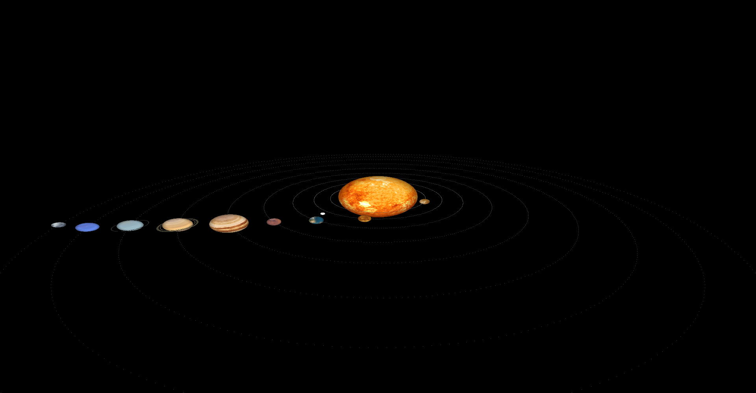

**Initial view of the model**

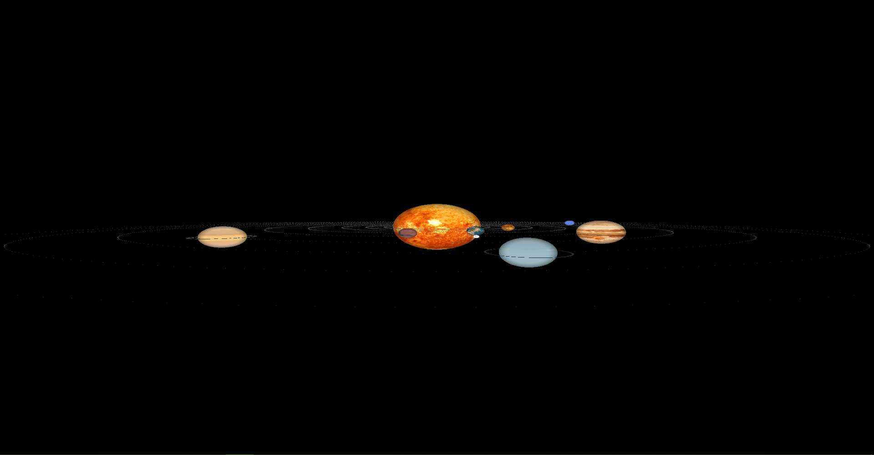

**The Cross sectional view**

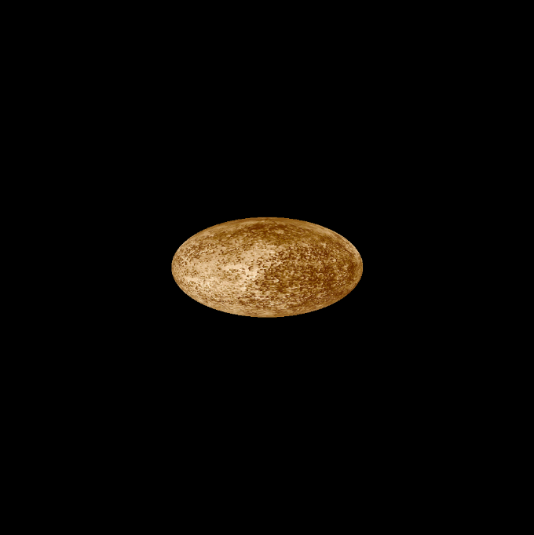

**Mercury**

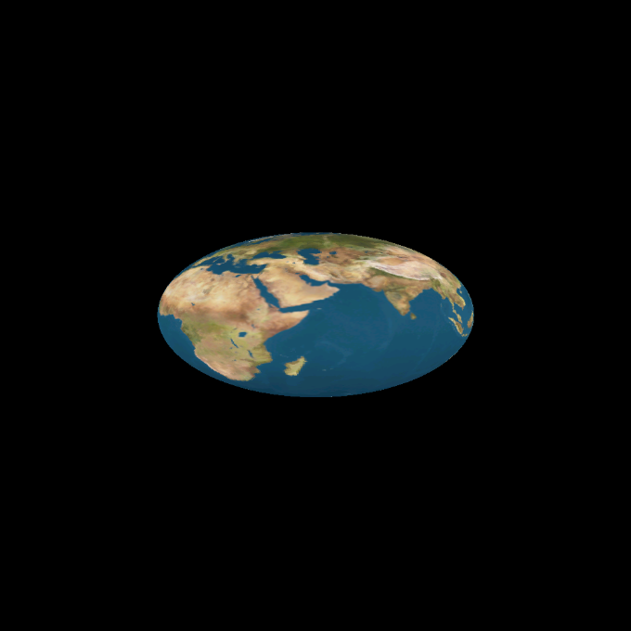

**Earth**

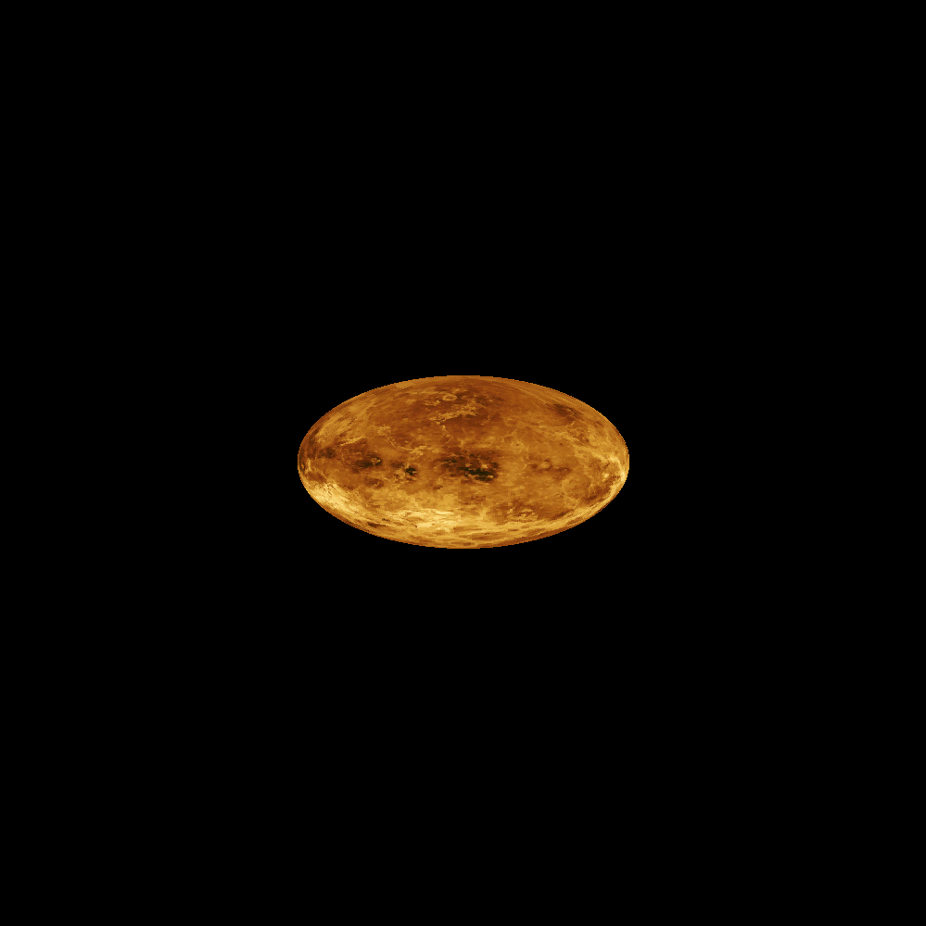

**Venus**

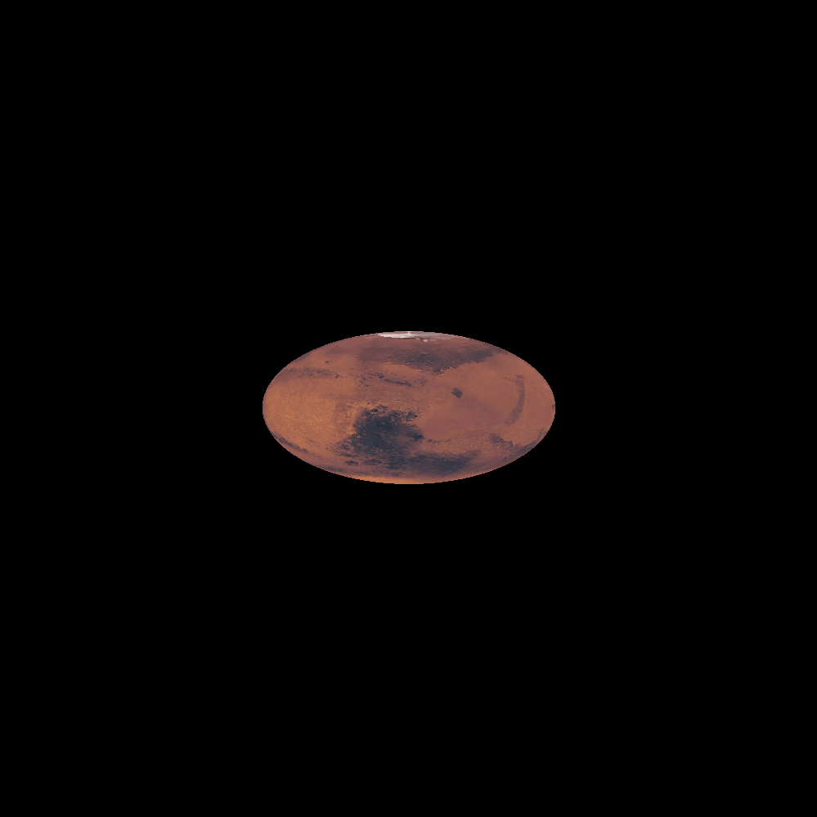

**Mars**

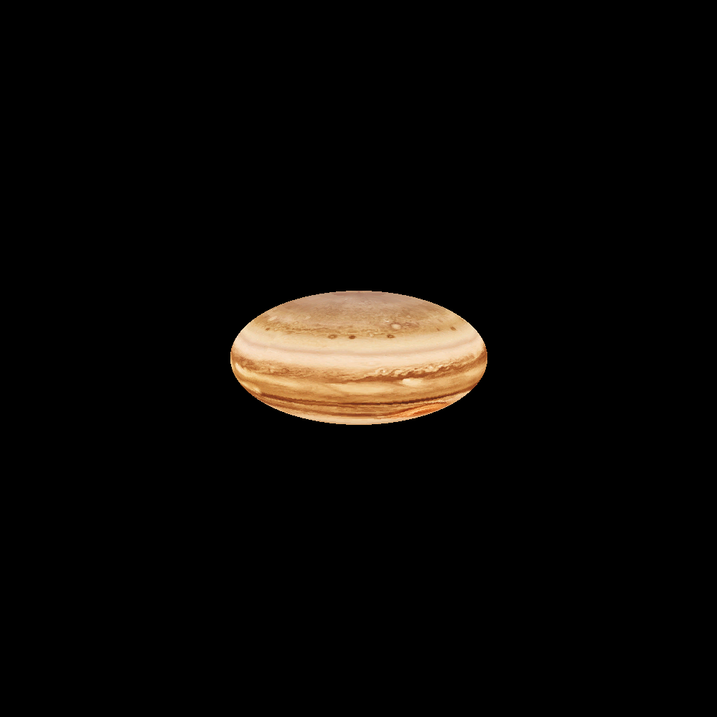

**Jupiter**

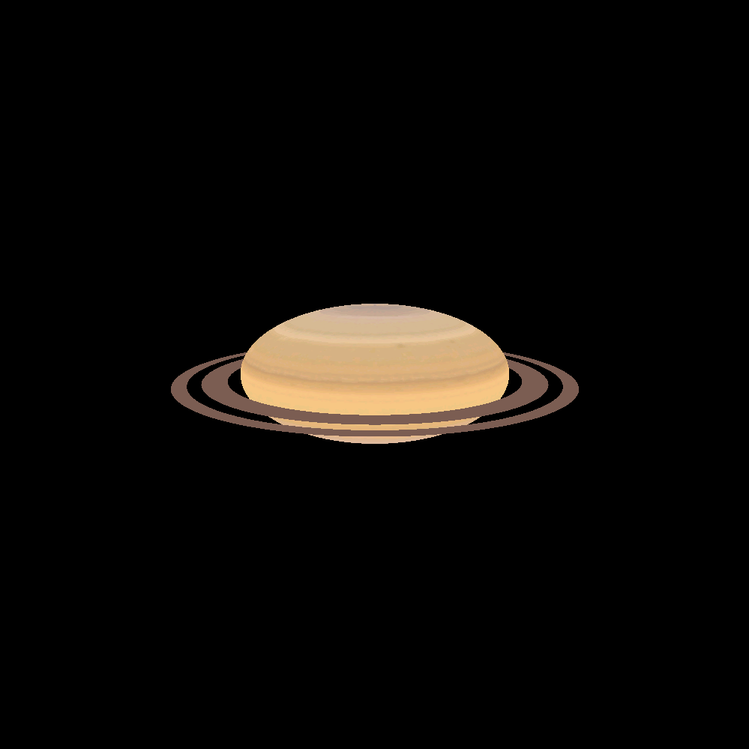

**Saturn**

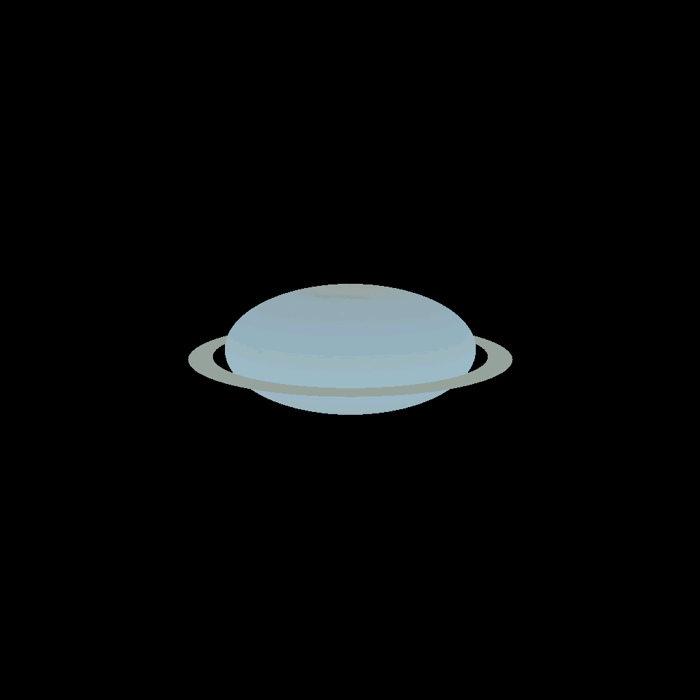

**Uranus**

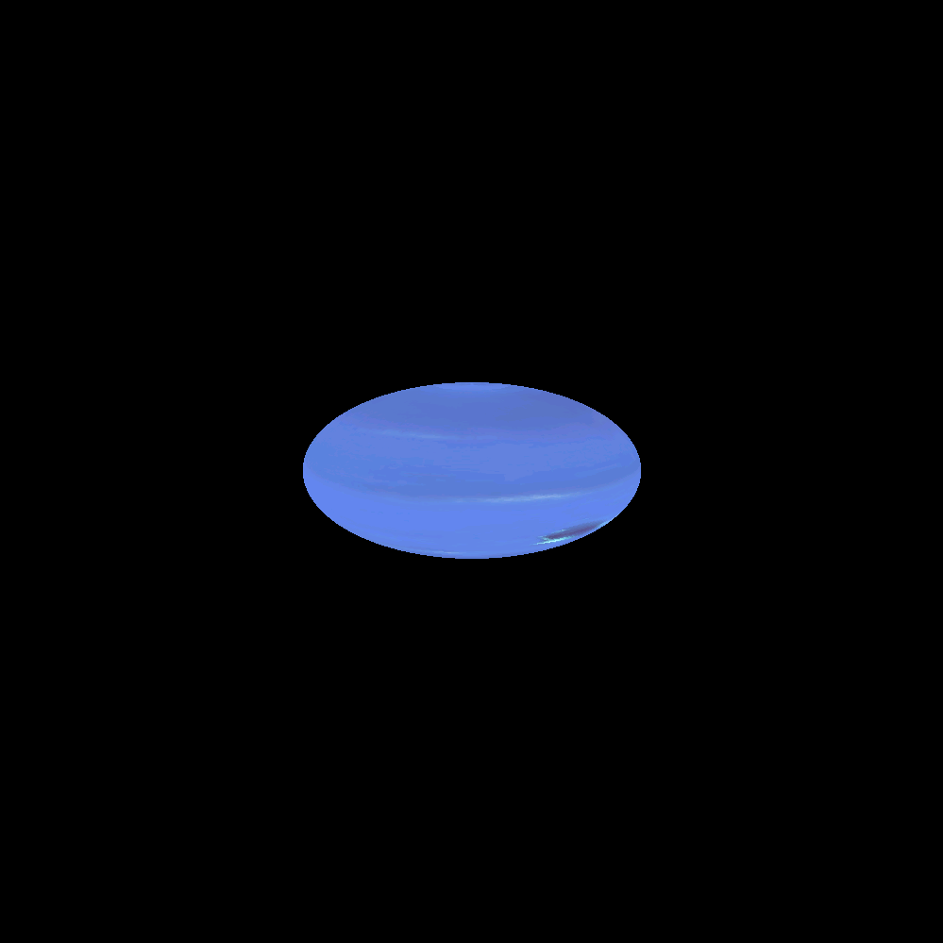

**Neptune**

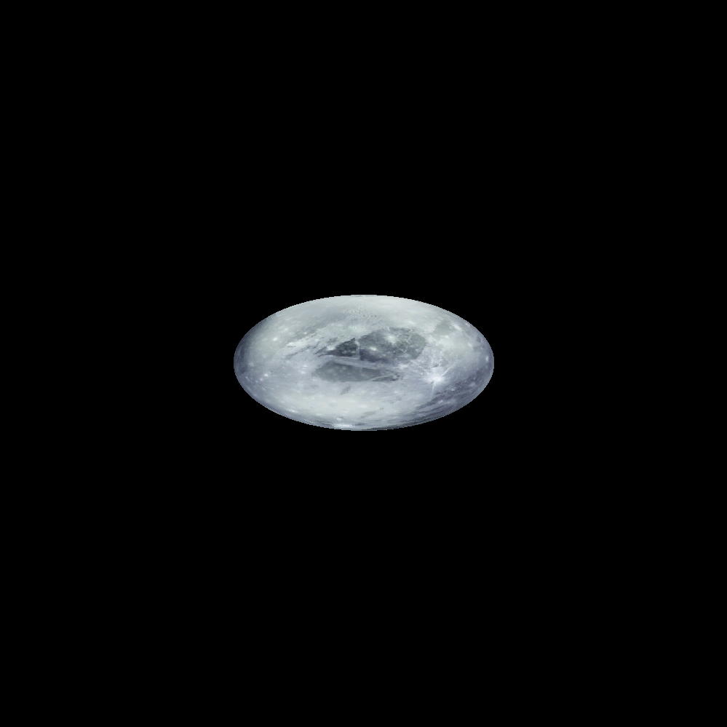

**Pluto**

**Chapter-6**

# CONCLUSION

Our project aims at displaying the 3D model of the solar system in OpenGL. Using built in functions provided by graphics library and integrating it with the C implementation of list it was possible to visually represent the objects in a 3D plane.

The described project demonstrates the power of Viewing which is implemented using different modes of viewing. The lighting and texture functions of OpenGL library add effect to the objects in animation.

The aim in developing this program was to design a simple program using OpenGL application software by applying the skills we learnt in class, and in doing so, to understand the algorithms and the techniques underlying interactive graphics better.

The designed program will incorporate all the basic properties that a simple program must possess.

The program is user friendly as the only skill required in executing this program is the knowledge of graphics.

**Chapter-7**

# FUTURE ENHANCEMENT

* We can try to simulate the solar system with precise orbits and revolutions.
* More functionalities, like displaying information about the planets, can be added.
* Orbits can be made elliptical, as is the original solar system instead of circular.
* Other celestial objects like moons, stars, asteroids and other such objects can also be included.

**Chapter-8**

# REFERENCES

**Books:**

1. The Red Book –OpenGL Programming Guide,6th edition.
2. Interactive Computer Graphics-A Top - Down Approach Using OpenGL, Edward Angel, Pearson-5th edition.

**Websites:**

1. http://planetpixelemporium.com/
2. http://www.glprogramming.com/red/
3. https://open.gl/textures
4. https://www.khronos.org/registry/OpenGL-Refpages/gl4/

**Chapter-9**

# APPENDIX

**9.1 User Manual**

* ‘x’ is used to reduce the x-coordinate of the camera.
* ‘X’ is used to increase the x-coordinate of the camera.
* ‘y’ is used to reduce the x-coordinate of the camera.
* ‘Y’ is used to increase the x-coordinate of the camera.
* ‘z’ is used to reduce the x-coordinate of the camera.
* ‘Z’ is used to increase the x-coordinate of the camera.
* ‘q’ is used to quit the program.
* ‘+’ is used to increase revolution speed to set value.
* ‘-’ is used to reduce the revolution speed by set value.
* ‘ ’ (space) is used to pause the execution for 2 seconds.
* ‘r’ is used to reset the view back to all planets.
* The right mouse button displays the list of menu items to display each planet separately.

**9.2 Personal Details:**

**NAME:** SRINIVAS S IYENGAR [1DT14CS096]

SKANDA GHATE [1DT14CS093]

**SEMESTER:** VI

**DEPARTMENT:** DEPARTMENT OF COMPUTER SCIENCE AND ENGINEERING

**COLLEGE:** DAYANANDA SAGAR ACADEMY OF TECHNOLOGY AND

MANAGEMENT

**EMAIL-ID:** srinivas.iyengar8@gmail.com

ghate.skanda@gmail.com